PDM-17-Critical Design Review
/Users/Emmet/Projects/PDM-2017/Reviews/

Mini Schematic

Net Double Ups
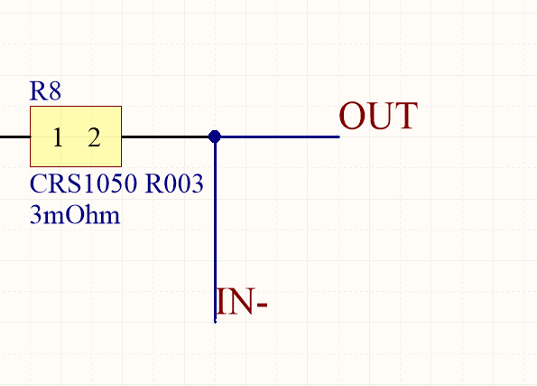
Altium really doesnt like giving the same net two different names. Here we have either OUT or IN-. It will lead to confusion and sadness if we leave it like this. I have ditched the IN- in favour of just OUT.

Net Names
I know this is really picky, but if we can its awesome to have super well defined/descriptive net names. IN+ and OUT are a tad bit off, next time something like CURRENT_SIG-, HIGH_POWER_OUT might be a good idea

TP TODO
- Check Gain for current sense
- Shunt Power Capabilities

